Assignment-2



Assignment-2: Write a script that reads numbers from the user until they enter '0'. The script should also print whether each number is odd or even.

Shell script code with the name of evenodd.sh:
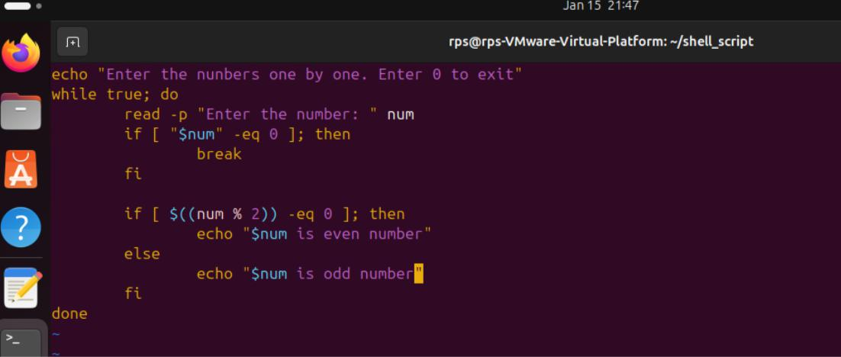

Commands to run evenodd.sh and checking its function:
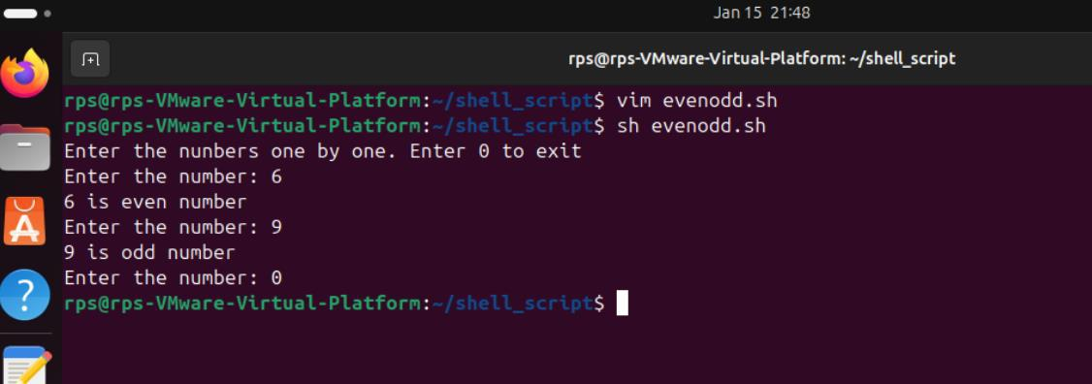
21

21958-Lokesh_Panem

